ANCIENT VILLAGE FIRE ESCAPE PATH PLANNING BASED ON IMPROVED ANT COLONY ALGORITHM

Wei Xia, Kang Cao, QianChuan Hu

Laboratory of Electronic Innovation(Anhui Jianzhu University),Hefei,230601,China

ahxw1101@126.com,caokang0428@sina.com,827953776@qq.com

Keywords: ancient village; fire escape; path planning; ant colony algorithm

Abstract
The roadways are narrow and perplexing in ancient villages, it brings challenges and difficulties for people to choose route to escape when a fire occurs. In this paper, a fire escape path planning method based on ant colony algorithm is presented according to the problem. The factors in the fire environment which influence the escape speed is introduced to improve the heuristic function of the algorithm, optimal transfer strategy, and adjustment pheromone volatile factor to improve pheromone update strategy adaptively, improve its dynamic search ability and search speed. Through simulation, the dynamic adjustment of the optimal escape path is obtained, and the method is proved to be feasible.

1 Introduction
Nowadays the ancient village set residential, tourism, commercial and workshop in one, personnel gathering, and most of the roadways are narrow and perplexing. The most ancient village buildings are built of wood or brick ^{[1]}, there are many flammable substances, and with low fire resistance grade, so it is easily to cause fire. In case of fire, it is difficult to find the exit especially for tourists, then blocking roadways and influencing escape. The path planning and guidance is given to ensure that personnel can quickly find the optimal escape path in complex terrain in ancient village. At present, the main research path planning methods are genetic algorithm, simulated annealing algorithm, particle swarm optimization algorithm and ant colony algorithm ^{[2]}.
The positive feedback mechanism^{[3]} is adopted in ant colony algorithm. The mutual cooperation of the escape path choice when the fire occurs is similar to the mutual cooperation of the information exchange between the ants. So, in this paper the ant colony algorithm is used as a mathematical algorithm in the model. Firstly, analyse the factors which influence the escape speed in fire environment. Then convert factors into functions, improve ant colony algorithm heuristic function, optimal transfer strategy, adjust pheromone volatile factor to improve pheromone update strategy adaptively, in order to improve the dynamic search ability and search speed of the algorithm. Finally, the rationality and effectiveness of the method are proved by simulation.

2 Analysis of the factors affecting the escape speed in the fire environment
High temperature, population density and roadway width are the key factors affecting the efficiency of personnel escape when a fire occurs. In this paper, the main factors are quantified and introduced into the model to realize the dynamic planning of the escape path in the fire environment.
Temperature influence coefficient 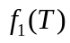, congestion coefficient 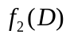 and difficulty coefficient of roadway traffic are introduced in this paper, then determine their quantitative methods on the basis of predecessors.
The effect of temperature on the escape personnel: the high temperature has less influence on the escape personnel when they feel uncomfortable, they will speed up the pace; with the rising of the fire temperature, the personnel walking speed decreased due to the high temperature smoke caused damage to the personnel. The United States Milke ^{[4]} summed up the impact coefficient on personnel movement speed calculation formula of temperature through a statistical study on temperature and speed of the personnel transaction data:
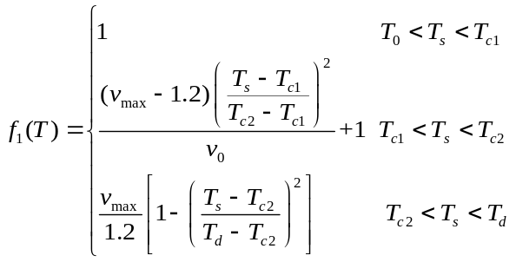 (1)
In formula (1), 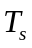 stands for fire temperature;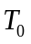 stands for temperature out of the door , take 20℃ ; stands for normal speed of walking; 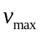 stands for maximum evacuation speed, take 5m/s, 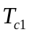 stands for uncomfortable temperature of human body, take 30℃;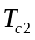 stands for the temperature that cause damage to the human body, take 60℃, 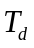 stands for the temperature that cause the death of a person, take 120℃.
Population density reflects the density of people in a space, the greater the density, the slower the speed. The congestion coefficient can be expressed by the following formula according to the SEGM model:
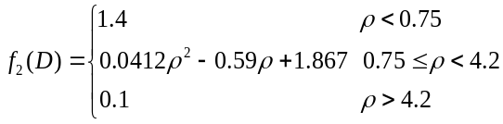 (2)
In formula (2),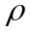 stands for population density (person/m²).
The width and the camber structure factors of roadway have a certain influence on the human walking speed. The width is also the basis for deciding whether to choose the roadway as an escape path. Combined with the existing personnel walking speed, and then simplify the difficulty coefficient of roadway with different width as shown in table 1.
Table 1: Simplified table of difficulty coefficient of roadway traffic with different width
condition of the road | average velocity (m/s)
spacious straight road | 1.20 | 1
roadway width is less than 3 meters | 0.70 | 1.71
roadway width greater than 3 meters | 0.85 | 1.41
3 Path planning modelling based on ant colony algorithm
3.1 Environment modelling
Mapping the actual terrain to a grid map with the grid method, grid identification with rectangular coordinate method. Abstract the terrain of the ancient village into network topology map G (V, E), V is a collection of nodes, E is a collection of paths. Node is divided into three categories: common node, obstacle node, and fire node.
Node V is defined as: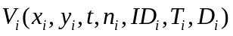.In which 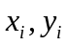 stand for two-dimensional space coordinates of nodes, they are static property, stands for time,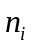 stands for the number of personnel at node V at time ,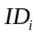 stands for safety identification at node 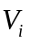, ordinary nodes represent the roadway, barrier nodes represent buildings that are obstacles to passage, fire nodes represent buildings that are breaking out of fire. ,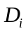 represent the temperature at node and population density respectively, they are static property.
Path set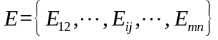, path 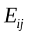 represents the escape path from node to node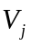. The two nodes can be passing when they are connected to each other, 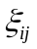 represents difficulty coefficient of roadway traffic for different paths, it is static property.
3.2 The Improvement of Ant Colony Algorithm
Ant Colony Algorithm is mentioned by Marco Dorigo^{[5]} in his doctoral dissertation. The algorithm has some characteristics, such as strong robustness, distributed computing mechanism and so on. However, there are some problems such as it takes too long to search and easy to fall into the local optimum. Adjustment pheromone volatile factor adaptively can accelerate the convergence and improve the global search ability.
In the path searching process, escape personnel choose the direction of advance based on the concentration of pheromone in the path. The tabu list 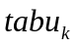 is used to represents the node set by the person k that already passed. The tabu list is adjusted dynamically in the process of the algorithm. The escape personnel determine the state transition probability according to the pheromone 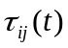 and the heuristic function 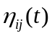 from each path.
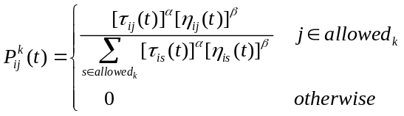 (3)
In formula (3), represents concentration of pheromone on path (i , j) at time t; is heuristic function, it represents the degree of expectation which ants from node i move to node j,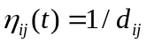,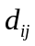 represents the geometric distance from i to j;andrepresent the importance degreeandrespectively;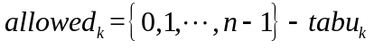represents the selectable grid collection of personnel k at present.
It can be seen from formula (3), personnel choose the path mainly rely on pheromone concentration and heuristic function. The heuristic function is related to the environment, this paper will inspire the heuristic function to make the following improvements:
It can be known that the shortest path is not necessarily the best way to escape from the above analysis, selection strategy must be changed. In this paper, the activity index of personnel 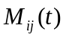 and the difficulty coefficient of roadway traffic are introduced to calculate the equivalent distance 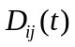^{[6]} of escape path, and then improve the heuristic function.
The activity index of personnel is calculated by the temperature influence coefficientand the congestion coefficientfrom the above analysis, the expression of the personnel activity index is as follows:
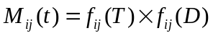 (4)
The expression of equivalent distance is as follows:
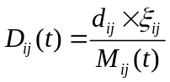 (5)
The geometric distance is replaced by the equivalent distance, the expression of heuristic function is as follows:
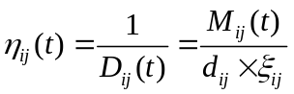 (6)
It can be seen from formula (6), and are inversely proportional to ,are in proportion to, in other words, personnel escape speed is reduced due to the impact of the environment, and the escape path also becomes longer accordingly, personnel is more inclined to choose the path of shorter equivalent distance.
Pheromone update strategy: ants update the residual information after one step or complete the traversal of n nodes. This approach is similar to the process of human brain memory which will gradually forget some of the old information after get new information. So the pheromone concentration can be reduced over time on each path. The pheromone update formula of the basic ant colony algorithm is as follows:
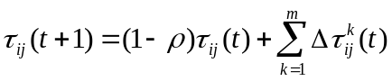 (7)
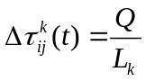 (8)
In formula (7), is called pheromone volatile coefficient,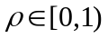, stands for the degree of reduction in pheromone; in formula (8),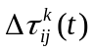 stands for the concentration of new pheromone, stands for the increase strength of pheromone,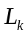 stands for the total length of the cycle is completed by ant k, that can be understood as the increase of pheromone concentration when personnel k through the path.
The value of affects the performance of the algorithm directly, the pheromone disappears quickly when the value is too large, and the global searching ability of the algorithm is restricted; the pheromone is not easy to disappear when the value is too small, and the convergence speed of the algorithm is reduced. In this paper, an adaptive method ^{[7]} to adjust the value of is proposed to solve the contradiction between the two problems mentioned above. Method setting: first set to a larger value, if the optimal solution did not change significantly after several iterations, the value of is obtained according to the following formula:
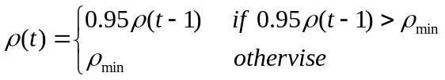 (9)
In formula (9), 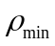 is the minimum value of, which is to prevent the value of become too small and prevent decrease the convergence rate of the algorithm.
4 Simulation steps and result
4.1 Simulation steps
In order to verify the effectiveness of the algorithm, set M=5,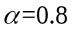,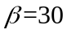,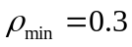,K=200,Q=1, environment is 33×33 grid, the pixels of small square is 1, the path does not participate in the path search which less than a grid. Simulating by MATLAB. The simulation steps are as follows:
Step1:Grid environment initialization, parameter initialization.
Step2:Conduct K round of iteration, selected the next node by roulette method according to the transfer probability formula.
Step3: Record the iteration path and length.
Step4: Update pheromone and empty tabu list.
Step5:If the iteration ends, output optimal path, the equivalent length, the convergence curve, the path search graph and the escape path graph; if not, go to step 2.
4.2 Simulation result
The simulation test is carried out for the single exit, set the coordinate of starting point for (16.5,21.5), set the coordinate of exit point for(28.5,1.5).
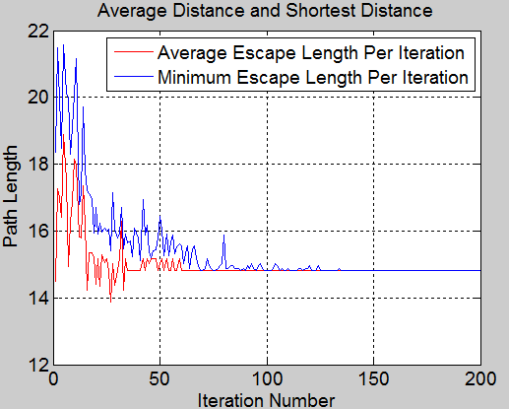
Figure 1: Path average distance and the shortest distance convergence curve
It can be known from figure 1, the shortest distance in the previous iteration is lower than the convergence value 14.4964, but the shortest distance is not necessarily the best escape distance, it is conform to the actual situation. In the 69th iteration, the average distance is equal to the shortest distance. The average distance and the shortest distance tend to converge after the 100th iteration, and remain stable, which shows that the algorithm has better convergence.
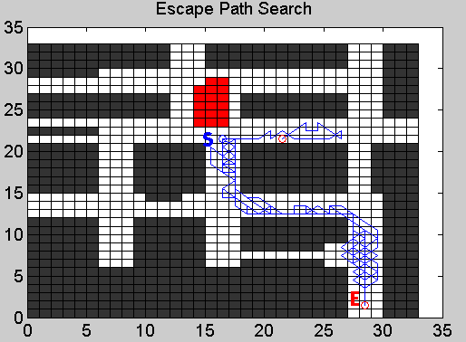
Figure 2: Single exit escape path search
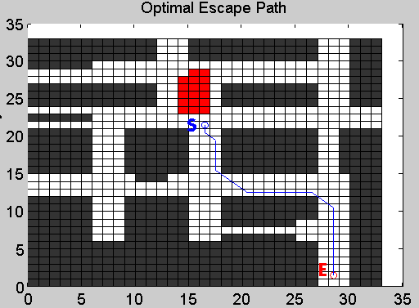
Figure 3: Single exit optimal escape path
The red part in figure 2 is the fire zone. Search path has certain randomness as can be seen from figure 2. The path in figure 3 is the final escape path given by the algorithm, the equivalent distance of this path is 14.4964, which is the shortest of all feasible paths. It shows that the algorithm has a certain ability to find the best.
Simulation results for two exits are shown by figure 4, figure 5 and figure 6.Set the coordinate of the starting point for (16.5, 21.5), set the coordinate of exit point 1 for (28.5, 1.5), set the coordinate of exit point for (28.5, 32.5).
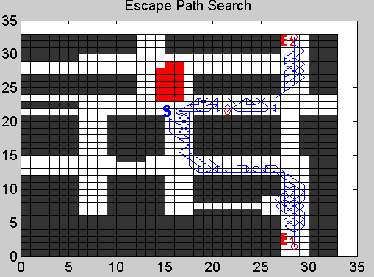
Figure 4: Two exit escape path search
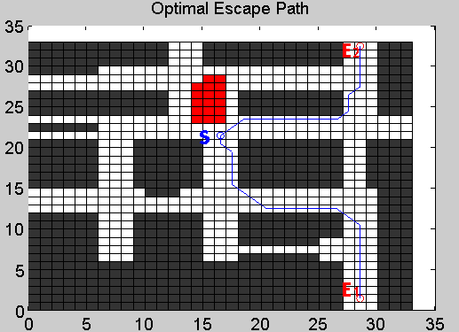
Figure 5: Two exit optimal escape path
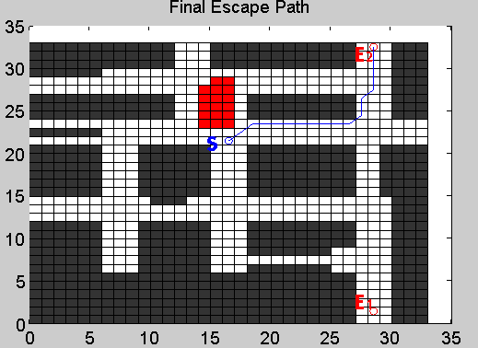
Figure 6: Final escape path
Figure 4 is a path search map with two exits, it can be seen that the search ability is better. The path in figure 5 is the optimal escape path for each exit, the equivalent distance to exit 1 is 14.4964, and the equivalent distance to exit 2 is 11.6711. The fire has little effect in the early stage of the fire. The final escape path is given by figure 6 which the equivalent distance is the shortest; it shows that the algorithm has a good ability to find the best.
Assuming the fire spread trend is in order to verify the dynamic searching ability of the algorithm, and set the exit position to simulate. The coordinate of the starting point is (16.5, 21.5), the coordinate of the exit point 1 is (28.5, 1.5), the coordinate of the exit point 2 is (28.5, 32.5).
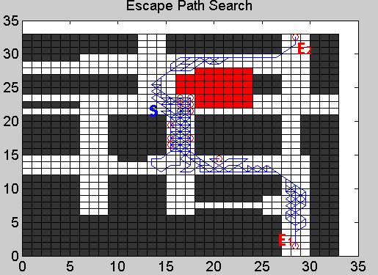
Figure 7: Fire spread escape path search
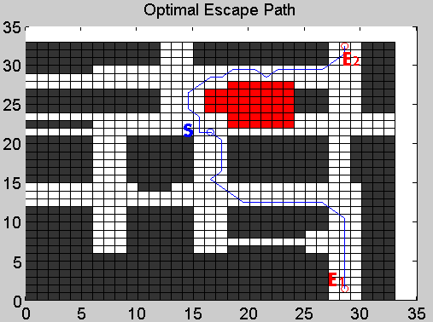
Figure 8: Fire spread optimal escape path
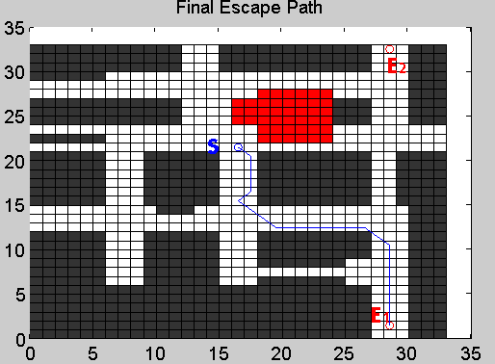
Figure 9: Fire spread final escape path
It can be seen that the fire is spreading to exit 2 from figure 7.Compared with figure 4, there is only one grid can be used in the original path as a search path due to the impact of the fire, therefore it is not choose as an escape path. Figure 8 shows the optimal escape path S1 and S2 for each exit after the fire spread, the geometric distance of S2 is less than S1, but the equivalent distance to exit 1 is 14.4964 due to the impact of the fire spread, the equivalent distance to exit 2 is 16.1230. Figure 9 shows the final escape path, the path with the shortest equivalent distance. The algorithm can adapt to the environment and can search the path dynamically.
5 Conclusions
This paper introduces the ant colony algorithm to select escape path quickly in the complex terrain environment in the ancient village when under fire. In the fire environment, the factors that affect the human traffic are convert factors into functions and then introduced into the transition probability, which can improve the adaptability and searching ability of the algorithm. The convergence of the algorithm is improved by pheromone update strategy. Simulation results show that the method can adapt to the environment, adjusting the search path dynamically, and improve the efficiency of personnel escape.
Acknowledgements
This work was supported by National Science and technology support program (Grant No.2012BAJ08B01) ,Key projects of natural science research in Anhui(Grant No.KJ2013A066), Doctoral Fund Project of Anhui Jianzhu University(Project name: Research on Key Technologies of construction safety prediction and evaluation).
Reference:
- ZhengKui Wang, GuangRong Wang. Talking about prevention of fire in ancient town [J]. Science and technology information,2010,29:238.
- Yong Liu. Research on optimal path of emergency rescue based on ant colony algorithm [D]. China University of Geosciences,2010.
- QingQuan Chen, DongNan Zhang, YongPing Zhang. Simulation of dynamic personnel evacuation based on ant colony algorithm [J]. Micro computer information,2012,10:424-426.
- Milke JA. Evaluating the early development of smoke hazard from fires in large spaces[J]. TRANSACTIONS-AMERICAN SOCIETY OF HEATING REFRIGERATING AND AIR CONDITIONING ENGINEERS, 2000, 106(1): 627-636.
- Dorigo M, Maniezzo V, Colorni A. Ant system: optimization by a colony of cooperating agents[J].IEEE Transactions on Systems Man & Cybernetics Part B Cybernetics A Publication of the IEEESystems Man & Cybernetics Society, 1996, 26(1):29-41.
- ChunYing Lei. Optimization of fire evacuation route based on improved ant colony algorithm [D]. WuHan University of Technology,2014.
- LiJun Zhu, ZhongQiu Yang. An ant colony algorithm for the adaptive mechanism of the lower and upper bounds of pheromone [J]. Journal of Shenyang Institute of Chemical Technology,2009,01:65-68.
- Zheng Xiang, Ming Xu, FoDe Wen. Simulation of evacuation in fire based on ant colony algorithm [J]. Security technology,2010,03:52-54+63.
- Dorigo B M, Vittorio. Maniezzo and Alberto Colorini: The Ant System: Optimization by a colony of cooperating agents[C]// IEEE Transactions on Systems, Man & Cybernetics. 2015.

